Lab7

Task4
#include <stdio.h>
#include <string.h>

int main () {

int score[10] = {12, 64, 42, 55, 91, 45, 74, 71, 13, 27};
int temp, i, j, median;

for (i = 0; i < 10; i++)
{
for (j = 0; j < 10; j++)
{
if (score[j] > score[j + 1])
{
temp = score[j + 1];
score[j + 1] = score[j];
score[j] = temp;
}
}
}

printf("Sorted Array: \n\n");
for (i = 0; i < 10; i++)
{
printf("%d ", score[i]);
}

median = (10 + 1) / 2;

printf("\n\n\nMedian Score is: %d", score[median]);

return 0;
}

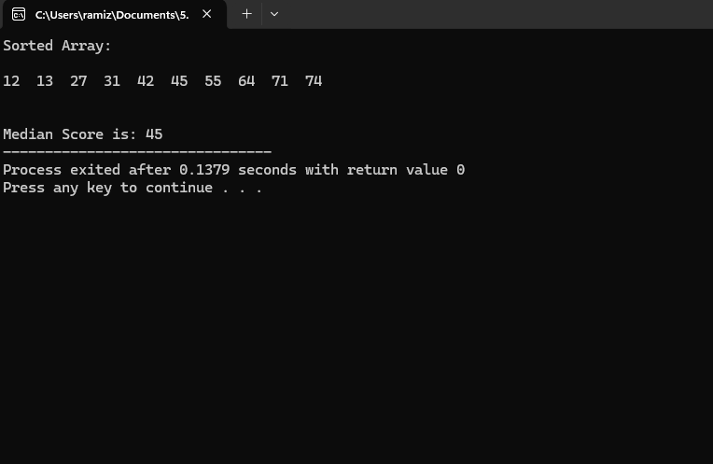

Task5

#include <stdio.h>

int main() {
int idx, lowest, highest, total, highestIdx, lowestIdx;
int scores[10];

printf("Enter a score: ");
scanf("%d", &scores[0]);
highest = scores[0];
lowest = scores[0];
total = scores[0];

for (idx = 1; idx < 10; idx++) {
printf("Enter a score: ");
scanf("%d", &scores[idx]);
total += scores[idx];

if (scores[idx] > highest) {
highest = scores[idx];
highestIdx = idx;
} else if (scores[idx] < lowest) {
lowest = scores[idx];
lowestIdx = idx;
}
}

float average = total / 10.0;

printf("\n\nScores before modification:\n\n");
for (idx = 0; idx < 10; idx++) {
printf("\nStudent %d score: %d", idx + 1, scores[idx]);
}

printf("\n\nLowest score was %d at index %d", lowest, lowestIdx);
printf("\nHighest score was %d at index %d", highest, highestIdx);
printf("\nAverage score: %.2f", average);

scores[lowestIdx] = 0;

printf("\n\nScores after setting lowest score to 0:\n");
for (idx = 0; idx < 10; idx++) {
printf("\nStudent %d score: %d", idx + 1, scores[idx]);
}

return 0;
}

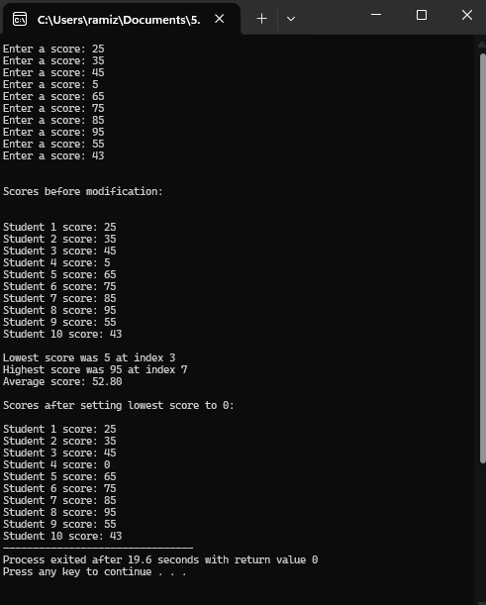

Task6
#include <stdio.h>

int main() {

int i, bNum[5], aNum[5];

for(i = 0; i < 5; i++)
{
printf("Enter a number: ");
scanf("%d", &bNum[i]);

aNum[i] = (((bNum[i] + 10) - 5) * 2);
}

printf("\n\nBefore Calculation \t After Calculation\n");
for(i = 0; i < 5; i++)
{
printf("%d \t\t\t %d\n", bNum[i], aNum[i]);
}

return 0;
}

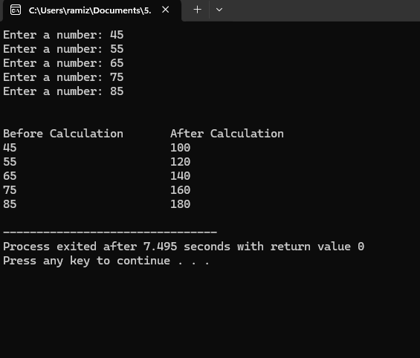

Task 7

#include <stdio.h>

int main() {
int removeID;
int newIndex = 0;
int itemList[10];
int updatedList[10];

for (int idx = 0; idx < 10; idx++) {
printf("Enter a 3-digit item ID: ");
scanf("%d", &itemList[idx]);
}

printf("Enter the 3-digit ID to delete: ");
scanf("%d", &removeID);

for (int idx = 0; idx < 10; idx++) {
if (itemList[idx] == removeID) {
itemList[idx] = 0;
} else {
updatedList[newIndex] = itemList[idx];
newIndex++;
}
}

printf("\n\nInventory after removal:\n");
for (int idx = 0; idx < 10; idx++) {
if (updatedList[idx] != 0) {
printf("%d ", updatedList[idx]);
}
}

return 0;
}

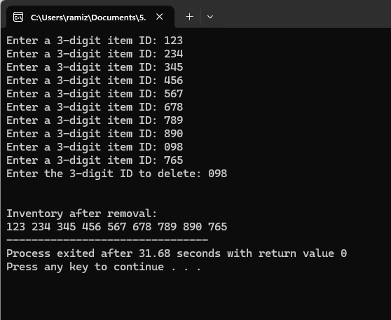

Task 8

#include <stdio.h>
#include <string.h>

int main() {
char word[100];
int i, wLen;

printf("Enter a word: ");
scanf("%s", word);

wLen = strlen(word);

for (i = 0; i < wLen; i++) {
if (word[i] == 'a') word[i] = 'A';
else if (word[i] == 'e') word[i] = 'E';
else if (word[i] == 'i') word[i] = 'I';
else if (word[i] == 'o') word[i] = 'O';
else if (word[i] == 'u') word[i] = 'U';
}

printf("\n\nWord after Changes: %s\n", word);

return 0;
}

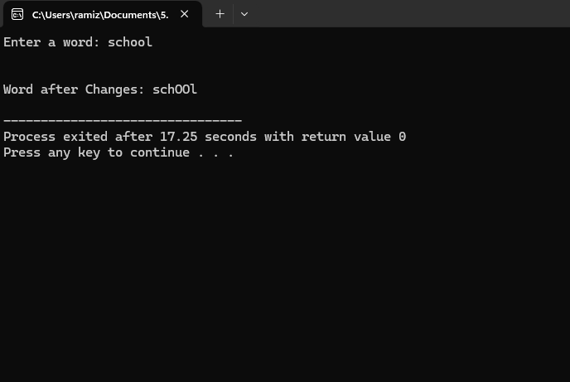

Task 9
#include <stdio.h>
#include <string.h>

int main() {
int firstSet[5];
int secondSet[5];
int combinedSet[10];

for (int idx = 0; idx < 5; idx++) {
printf("Enter value for first set: ");
scanf("%d", &firstSet[idx]);
printf("Enter value for second set: ");
scanf("%d", &secondSet[idx]);
}

for (int idx = 0; idx < 10; idx++) {
if (idx < 5) {
combinedSet[idx] = firstSet[idx];
} else {
combinedSet[idx] = secondSet[idx - 5];
}
}

printf("\n\nCombined Array:\n");
for (int idx = 0; idx < 10; idx++) {
printf("%d ", combinedSet[idx]);
}

return 0;
}
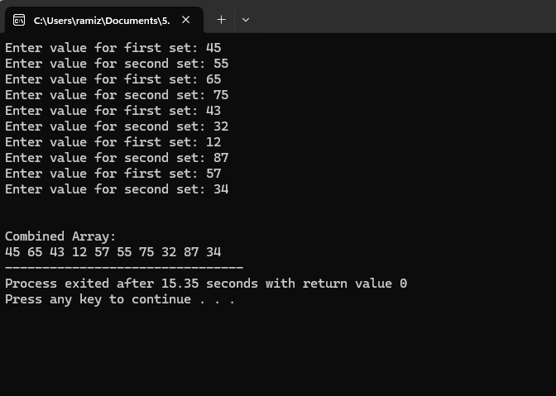

Task 10
#include <stdio.h>
#include <string.h>

int main() {
int length, inputNum, position, newValue;

printf("Enter the number of elements: ");
scanf("%d", &length);

int dataList[length];

for (int idx = 0; idx < length; idx++) {
printf("Enter element %d: ", idx + 1);
scanf("%d", &dataList[idx]);
}

printf("\nOriginal Array: ");
for (int idx = 0; idx < length; idx++) {
printf("%d ", dataList[idx]);
}

printf("\n\nEnter the position of the element to update: ");
scanf("%d", &position);
printf("Enter the new value: ");
scanf("%d", &newValue);

dataList[position - 1] = newValue;

printf("\n\nUpdated Array: ");
for (int idx = 0; idx < length; idx++) {
printf("%d ", dataList[idx]);
}

return 0;
}

